

* S3 – Oldest AWS service , Simple Storage Service That’s why S3

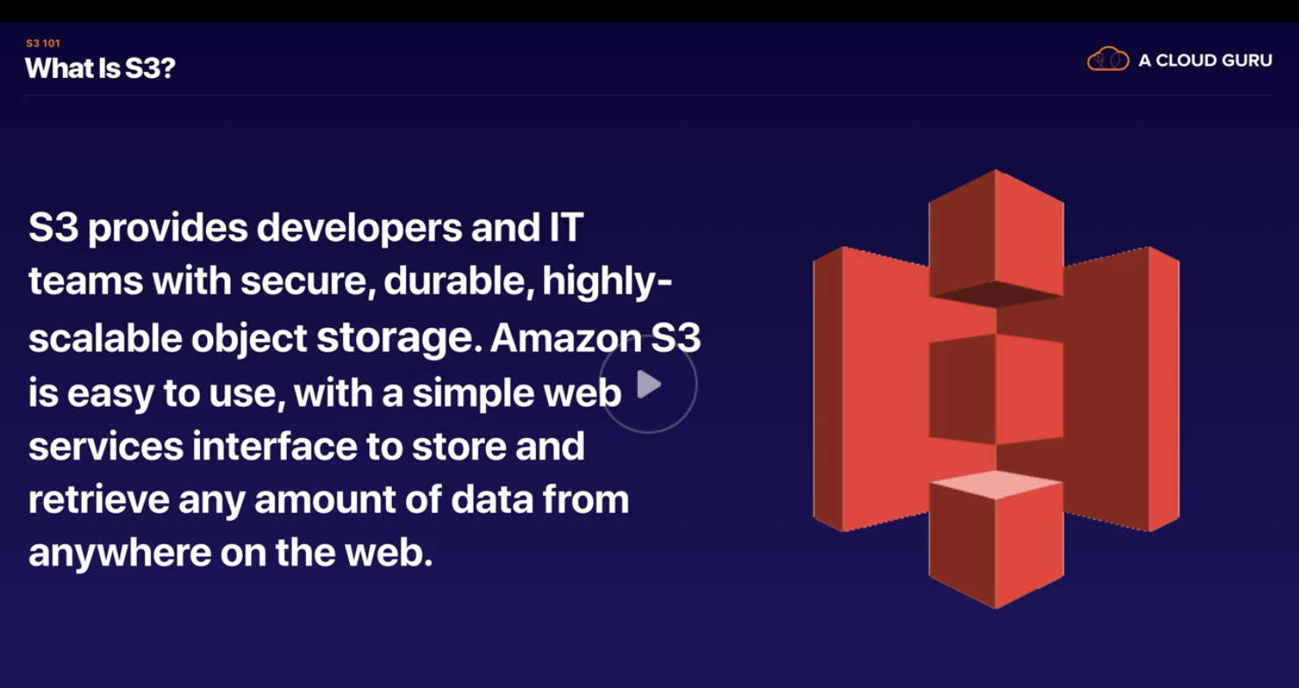

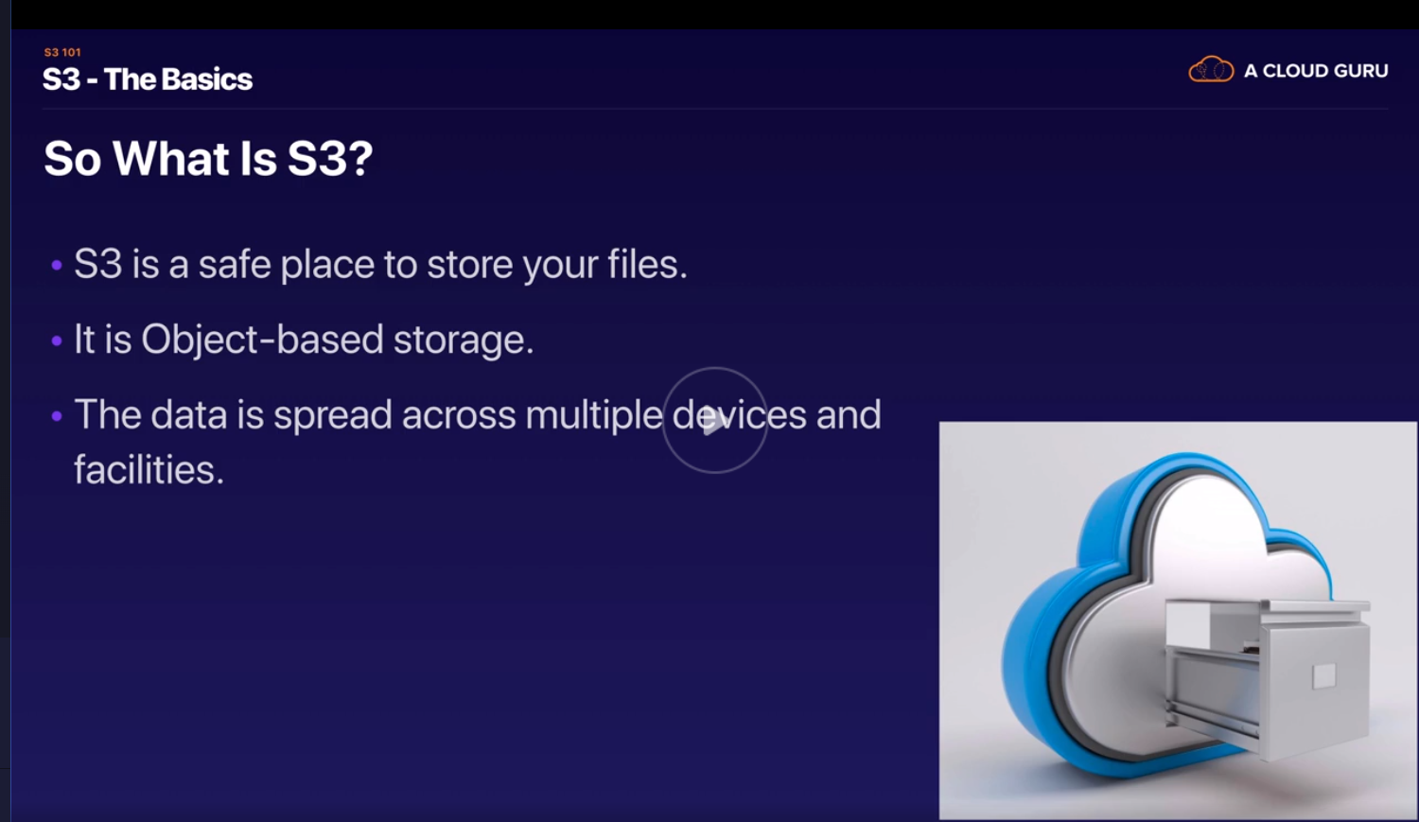

Buckets are nothing but folders

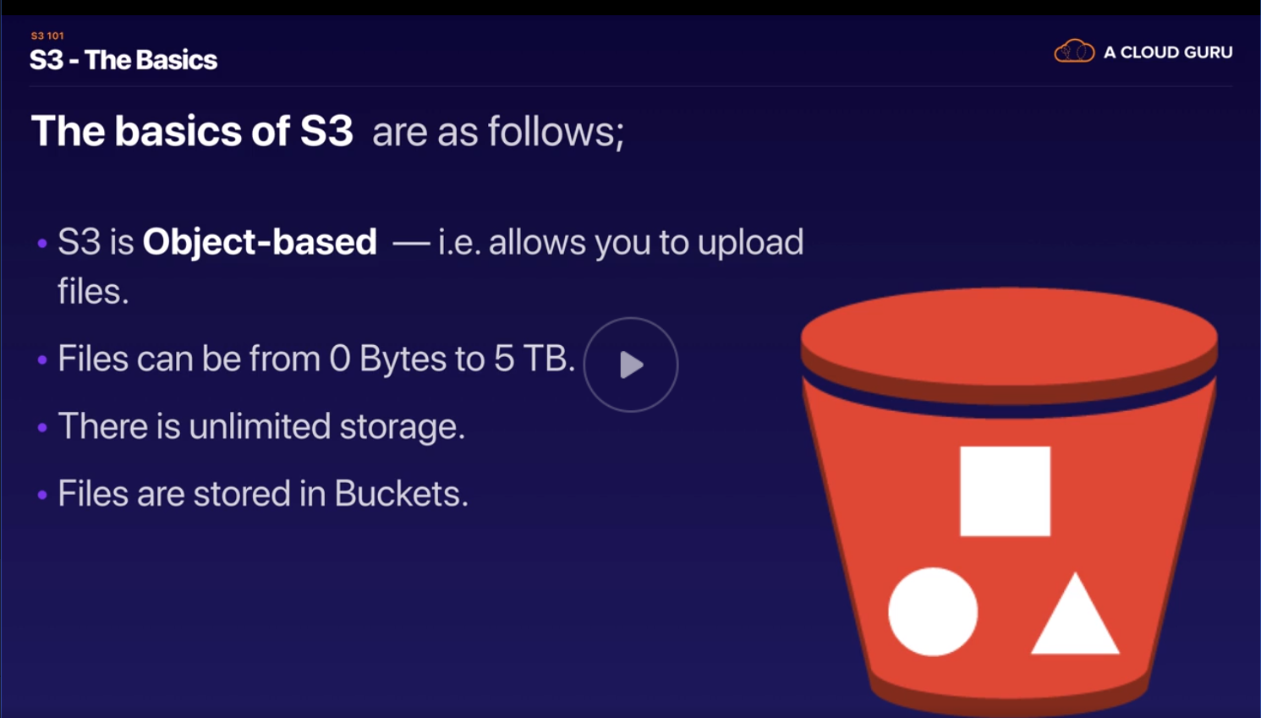

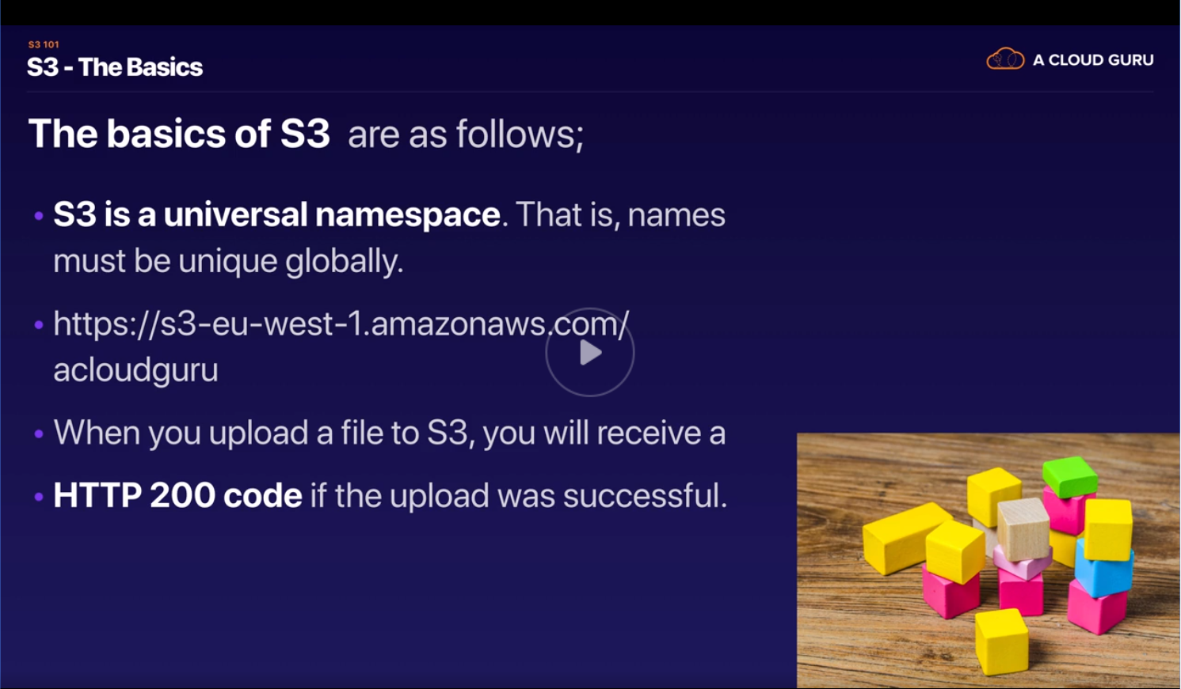

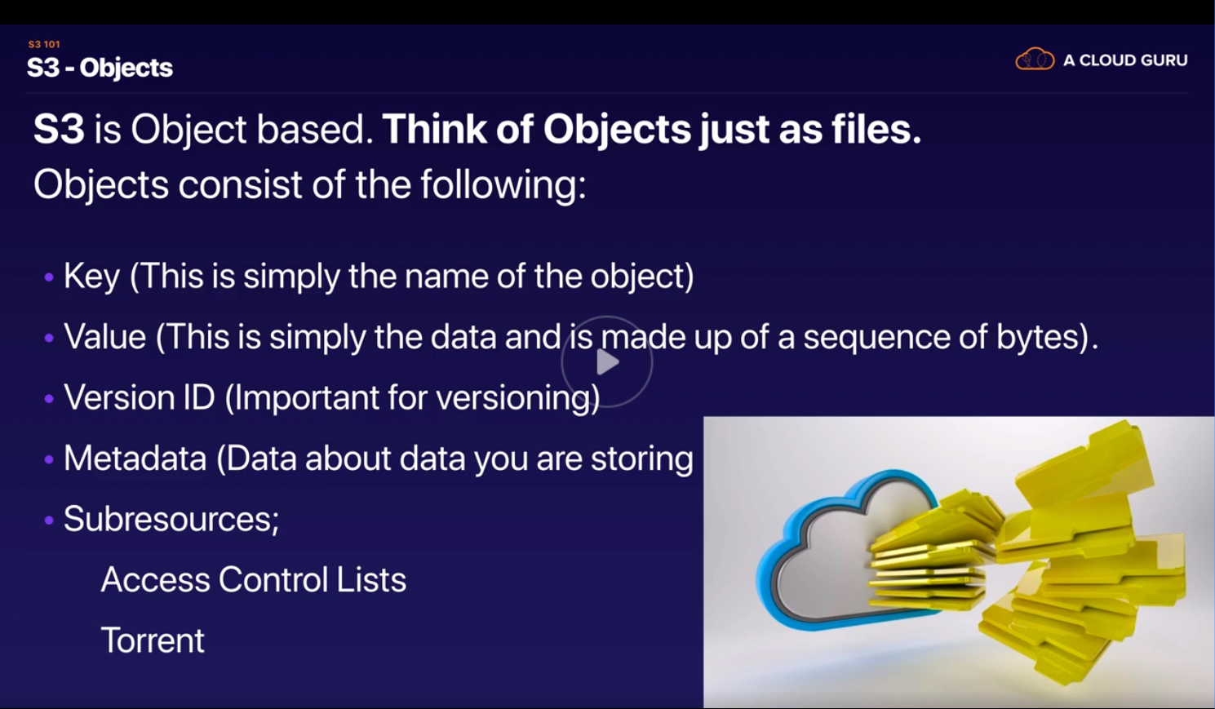



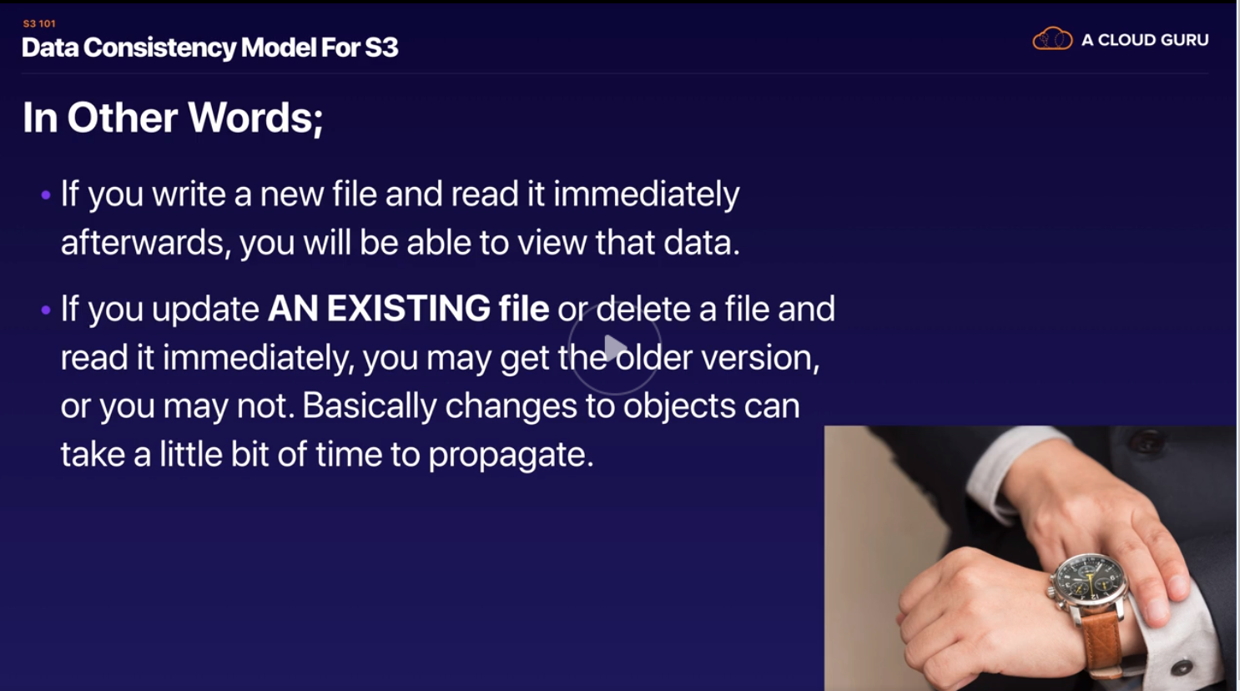

<https://www.youtube.com/watch?v=y-SbRy-6QRI> – Better explanation

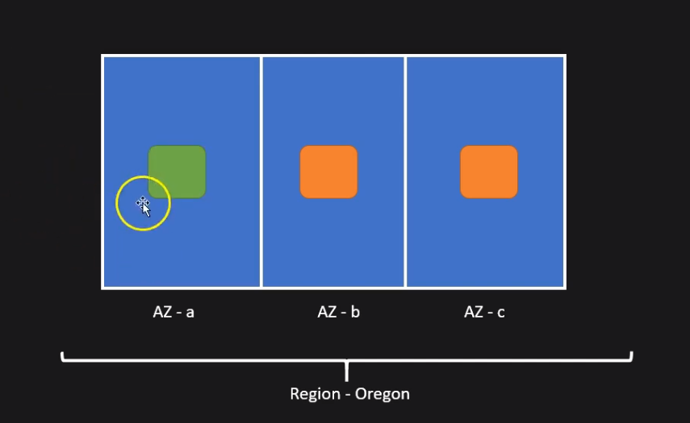

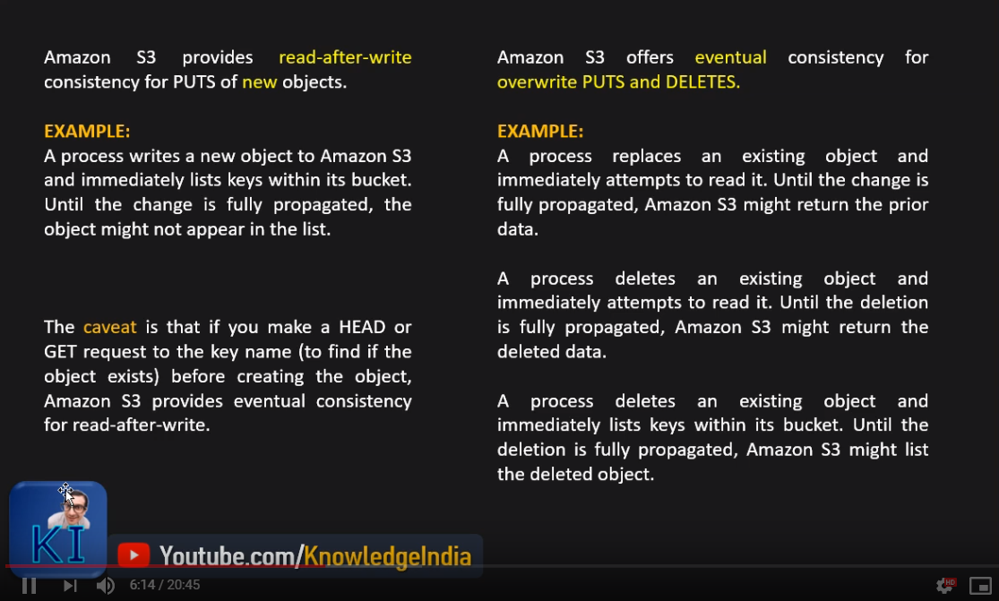

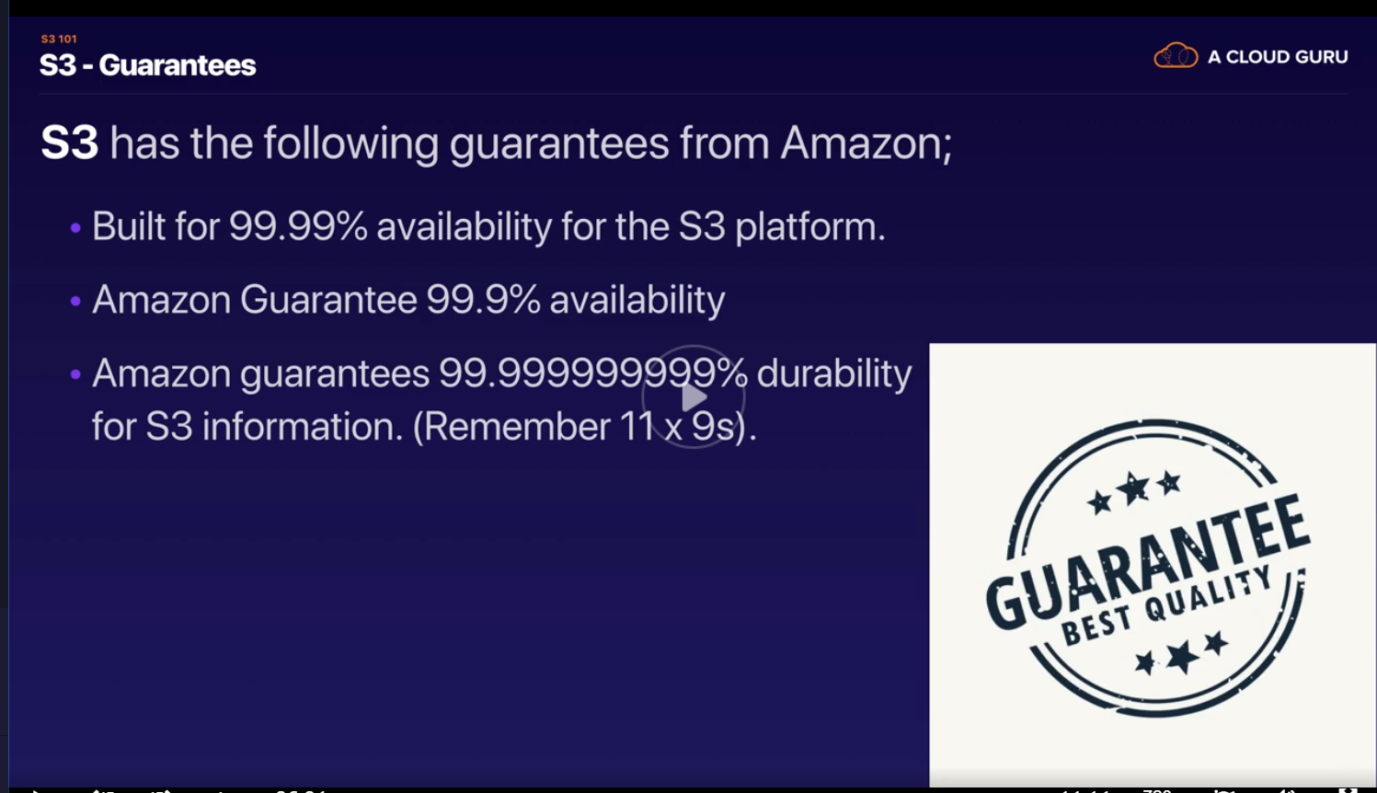

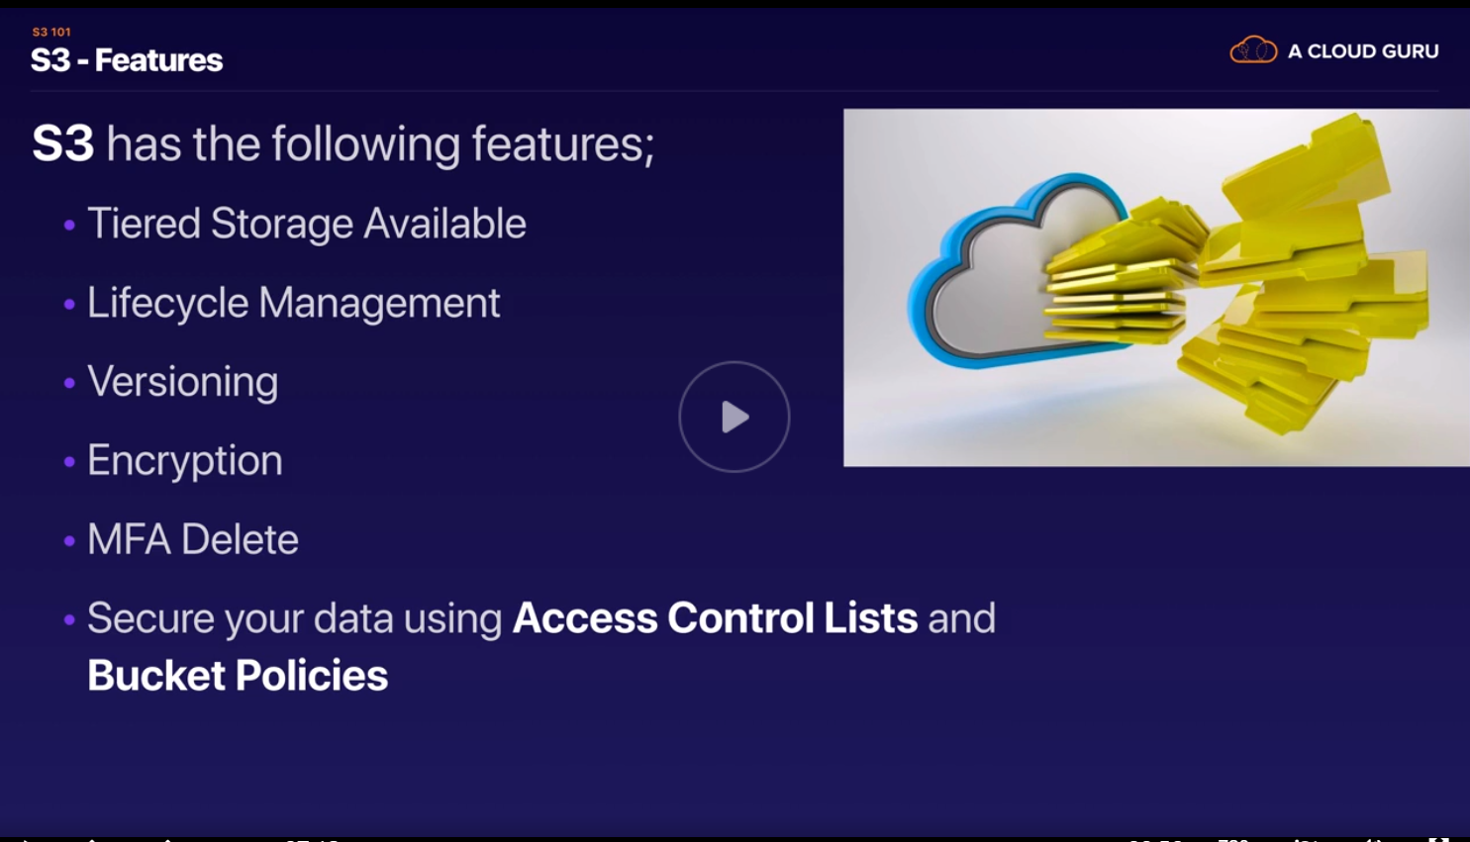

Tiered Storage is an important section for the exam

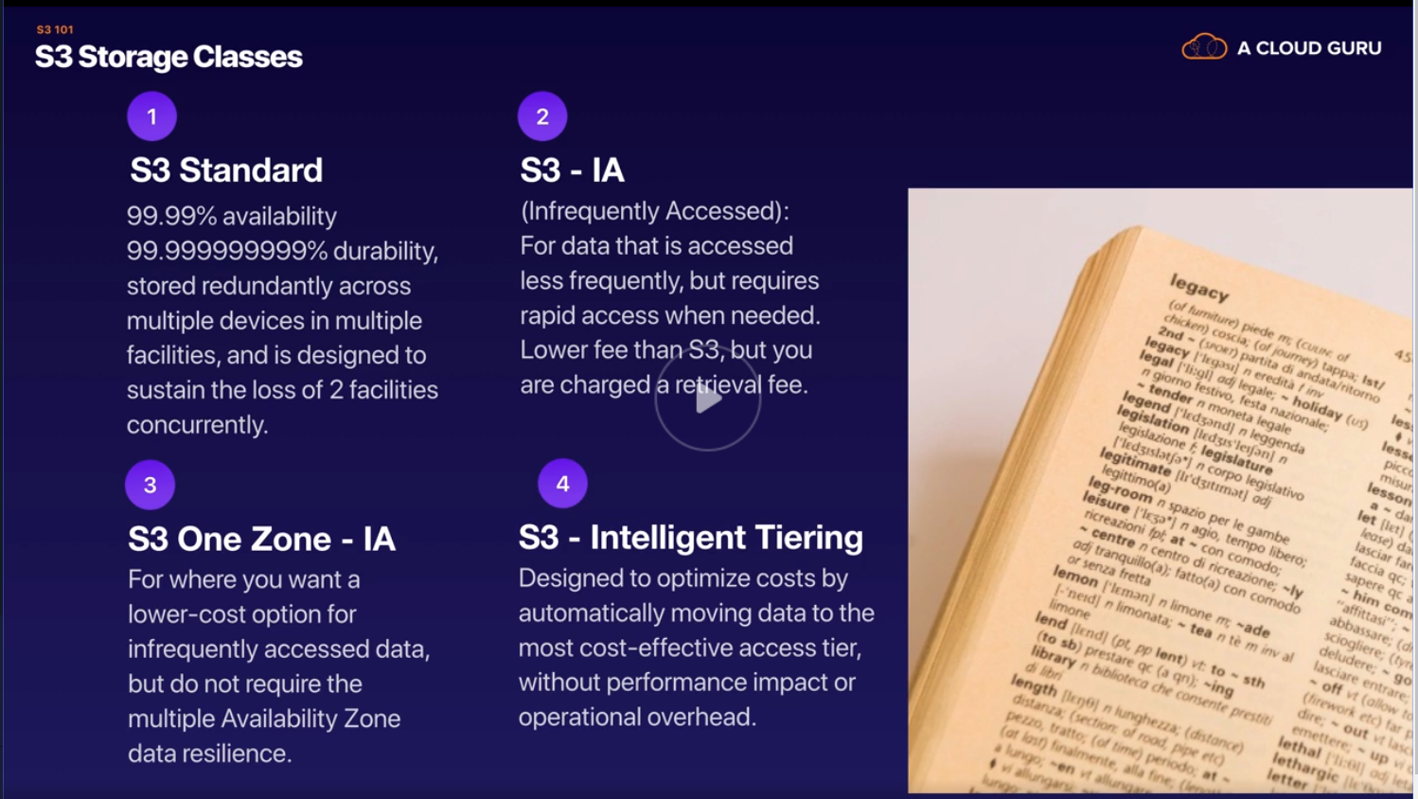

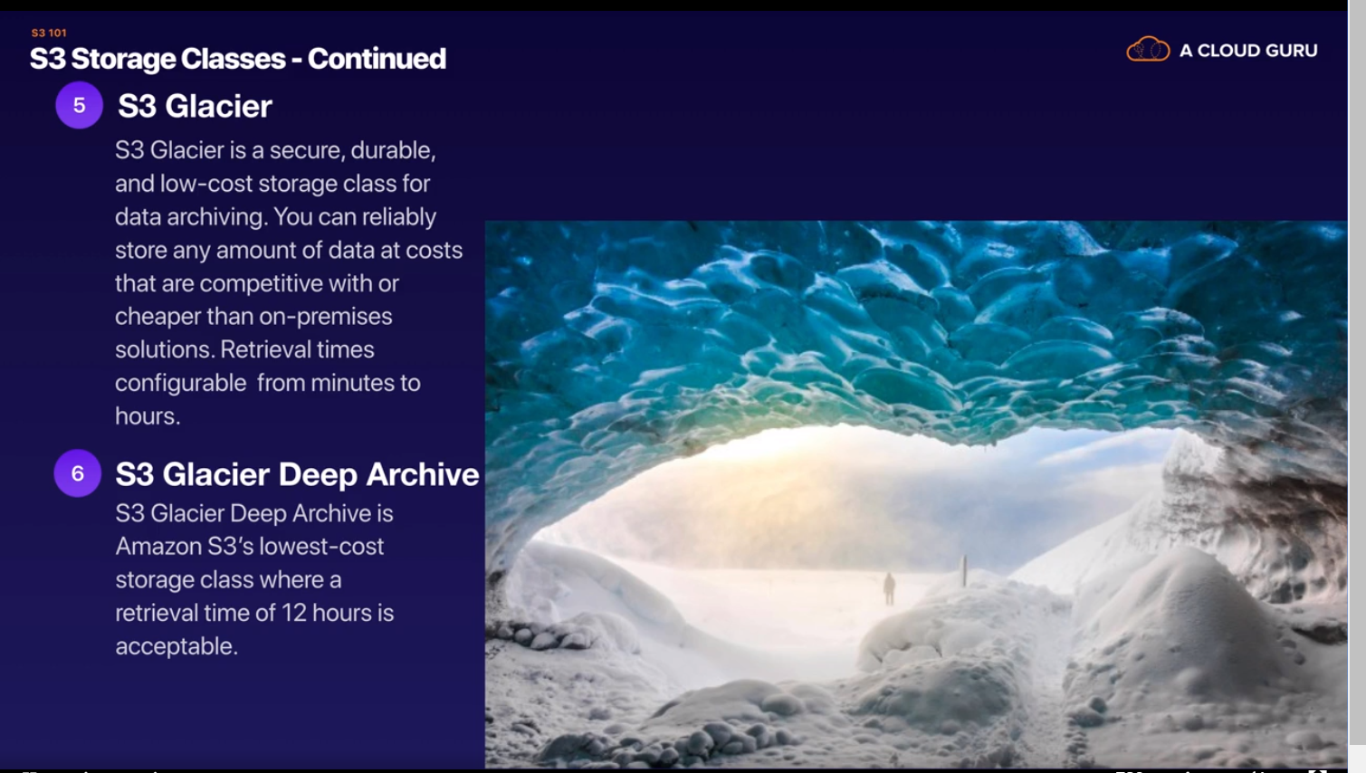

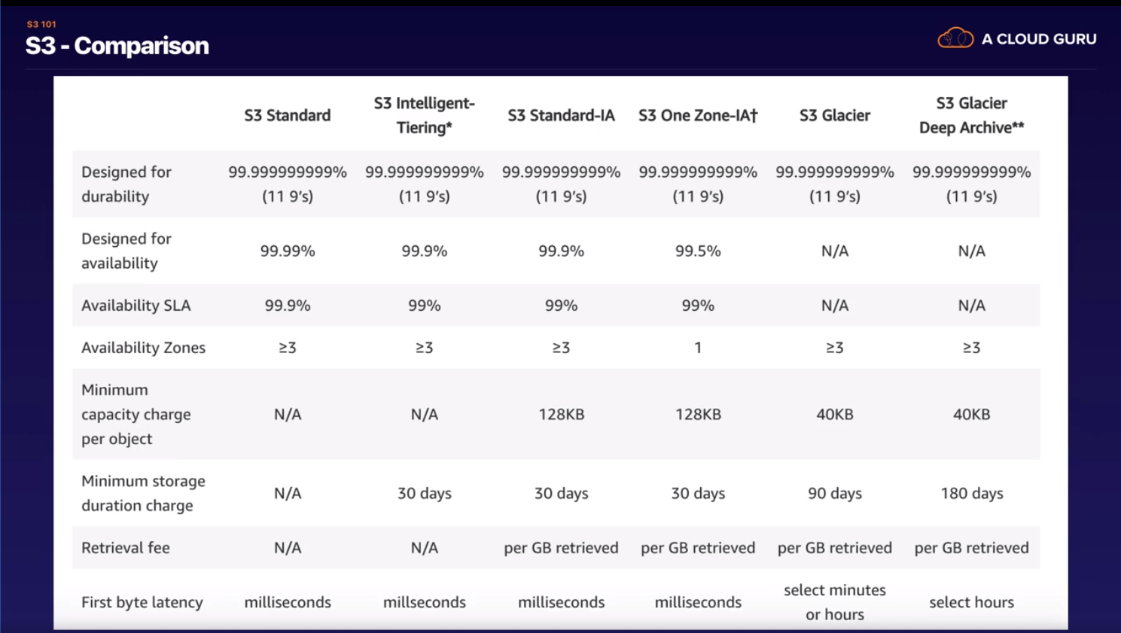

<https://www.youtube.com/watch?v=v-Ze0GbwkHg> – Storage Pricing explained very well here

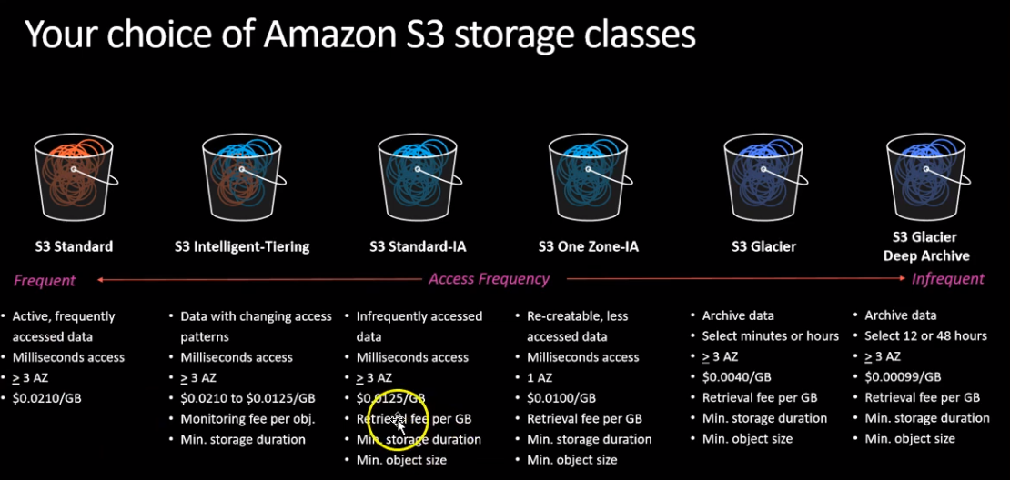

S3 Standard – Highest resiliency, 3 AZ within region

S3 Standard IA – same as S3 Standard with half the price for storage, but additional charge for retrieval per GB.

S3 Intelligent Tiering – This came to picture as users could not decide between standard IA and standard as they could not expect frequency for access could increase or decrease over a period of time (year ) . This observes access pattern and takes decision where to store. Since it is watching the access pattern there is additional monitoring fee.

Resilience is same for all above 3

RRD – Reduced redundancy storage – 2 AZs – comparatively price wise not much different from S3Standard IA, hence being discontinued

S3 One zone -IA – use this when you are ready to loose data when AZ goes down and recreate able

Additional retrieval fee

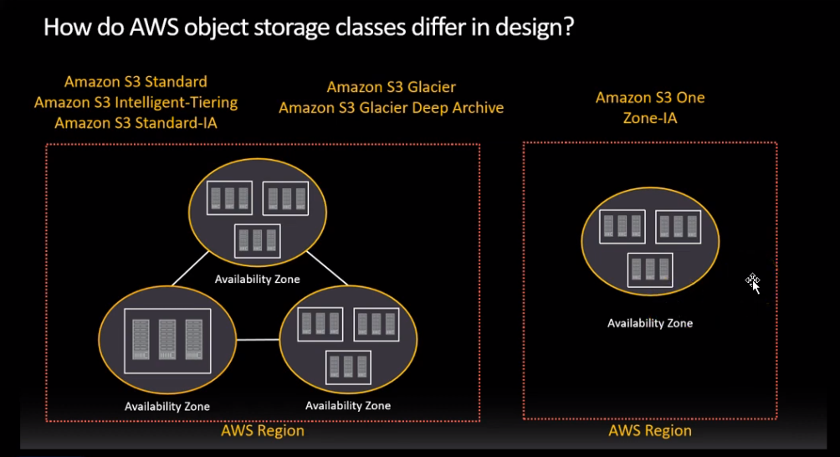

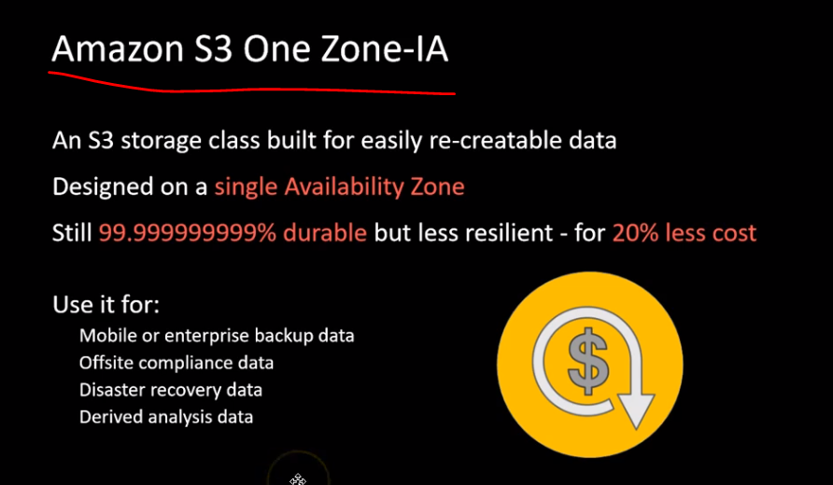

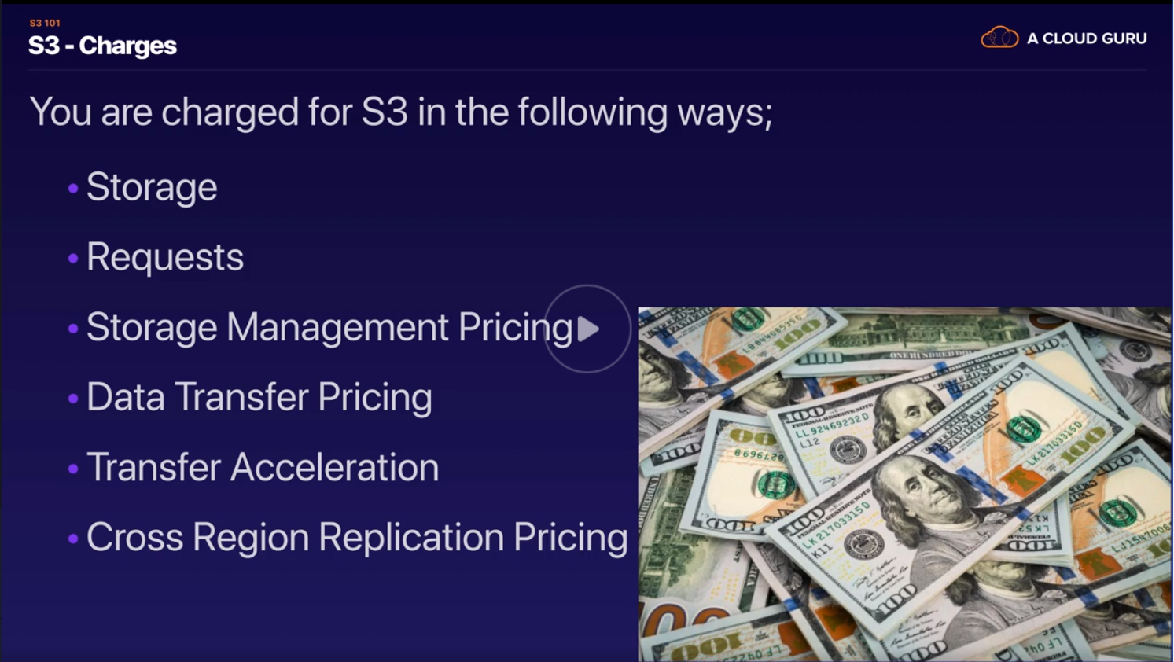

|  |  |
| --- | --- |
| Storage Pricing | Varies by size, duration except for S3 Standard |
| Request Pricing | varies by amount of data returned , additionally retrieval charges for IA onwards Notice the difference between retrieval and data returned |

|  |  |
| --- | --- |
| Data Transfer Pricing | Imagine a website with cloudfront and S3 1) Data transfer rates are calculated at cloudfront level 2) Data out (transfer) from S3 to cloudfront in free 3) S3 to EC2(service) -> Free if they are in same region else not , but cheaper than internet data transfer 4) All uploads to S3 buckets , data transfer price is zero |
| Transfer Acceleration Pricing | All uploads to S3 buckets , data transfer price is zero. We might use transfer accelerators to speed up the uplaods then there is a cost. The transfer accelarator tool checks the speed and charges only if speed is higher than normal upload speed |

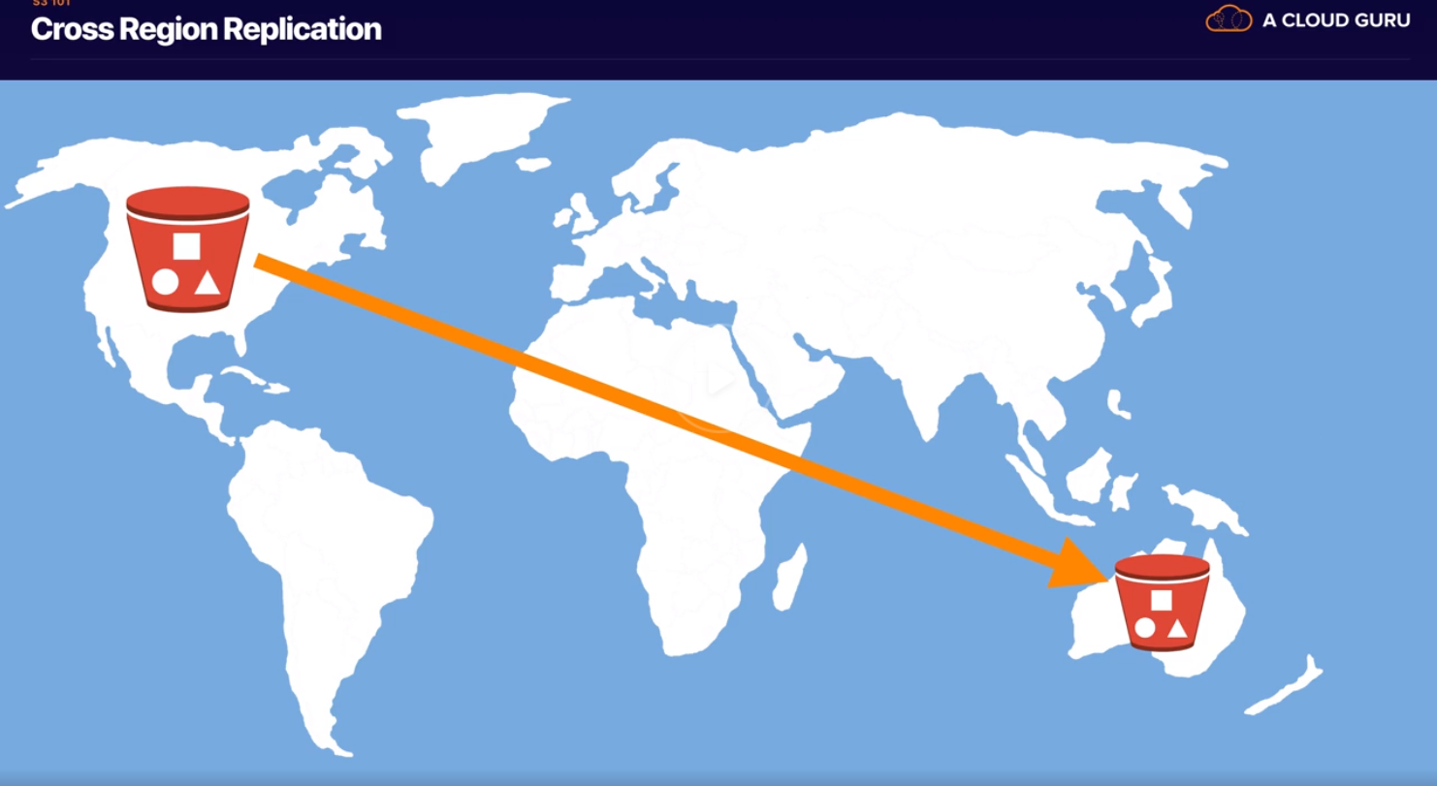

**Cross region replication Pricing**

Cross-region replication (CRR) enables automatic, asynchronous copying of objects across buckets in different AWS Regions. Buckets configured for cross-region replication can be owned by the same AWS account or by different accounts.

Cross-region replication is enabled with a bucket-level configuration. You add the replication configuration to your source bucket. In the minimum configuration, you provide the following:

The destination bucket, where you want Amazon S3 to replicate objects

An AWS IAM role that Amazon S3 can assume to replicate objects on your behalf

Additional configuration options are available

https://docs.aws.amazon.com/AmazonS3/latest/dev/crr.html

Cross-region replication can help you do the following:

Comply with compliance requirements—Although Amazon S3 stores your data across multiple geographically distant Availability Zones by default, compliance requirements might dictate that you store data at even greater distances. Cross-region replication allows you to replicate data between distant AWS Regions to satisfy these requirements.

Minimize latency—If your customers are in two geographic locations, you can minimize latency in accessing objects by maintaining object copies in AWS Regions that are geographically closer to your users.

Increase operational efficiency—If you have compute clusters in two different AWS Regions that analyze the same set of objects, you might choose to maintain object copies in those Regions.

Maintain object copies under different ownership—Regardless of who owns the source object you can tell Amazon S3 to change replica ownership to the AWS account that owns the destination bucket. This is referred to as the owner override option. You might use this option restrict access to object replicas.

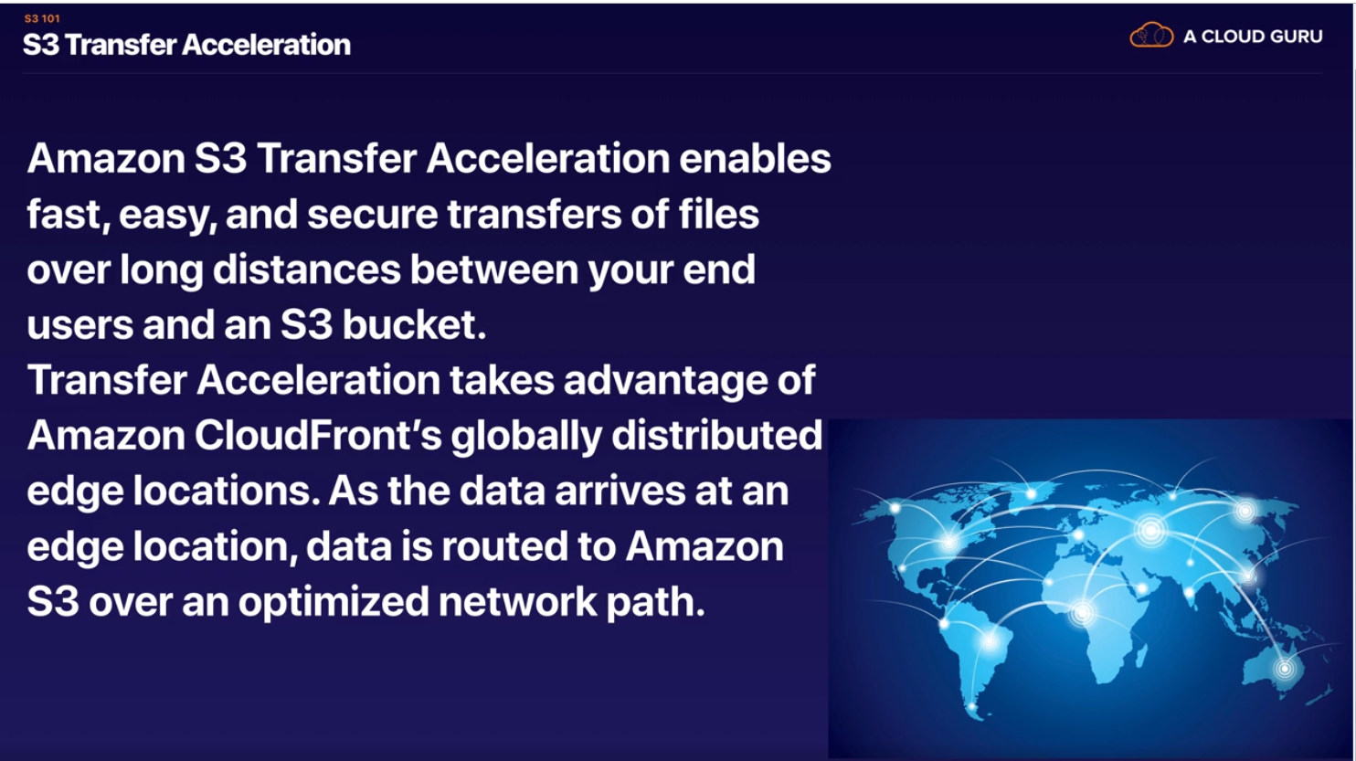

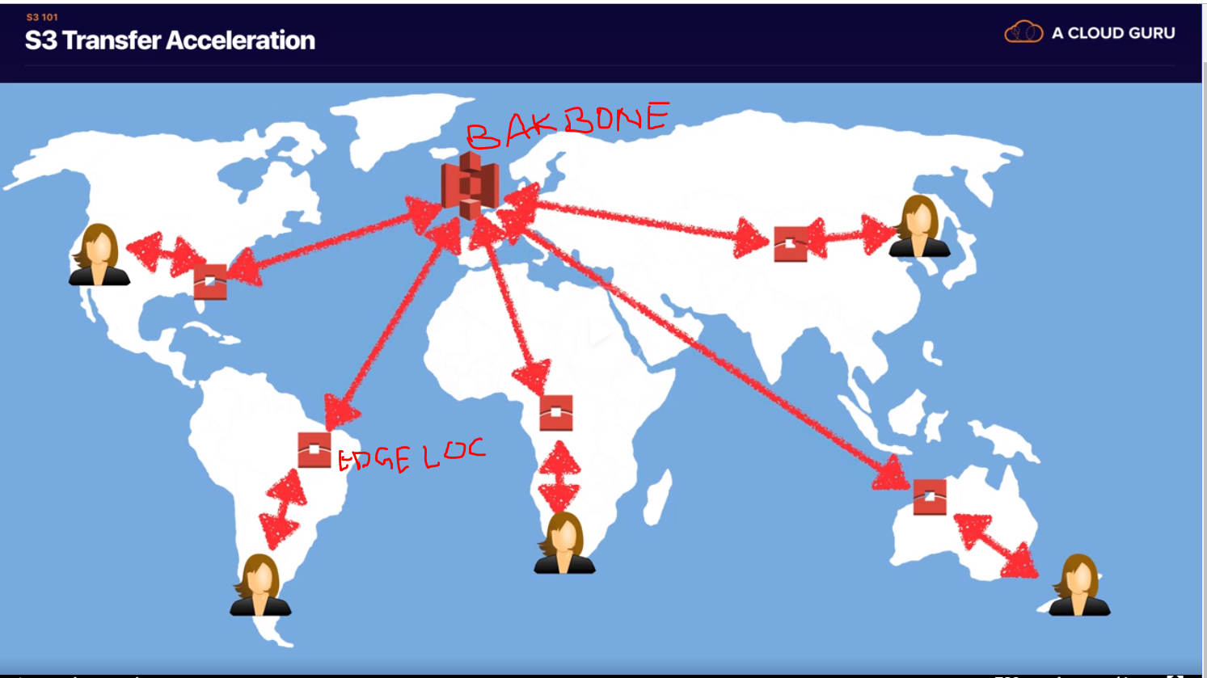

If you turn on S3 transfer acceleration facility, then Users upload files to edge location rather than S3 Bucket directly. Then from edge location file gets uploaded to S3 bucket they Amazon’s own backbone network.

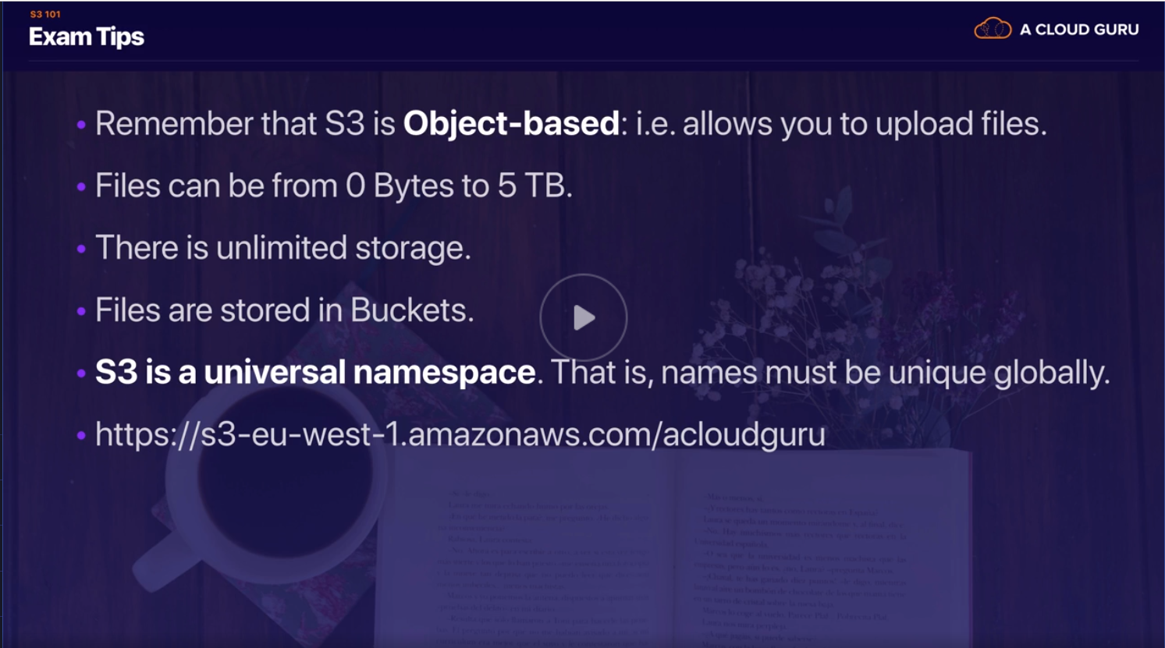



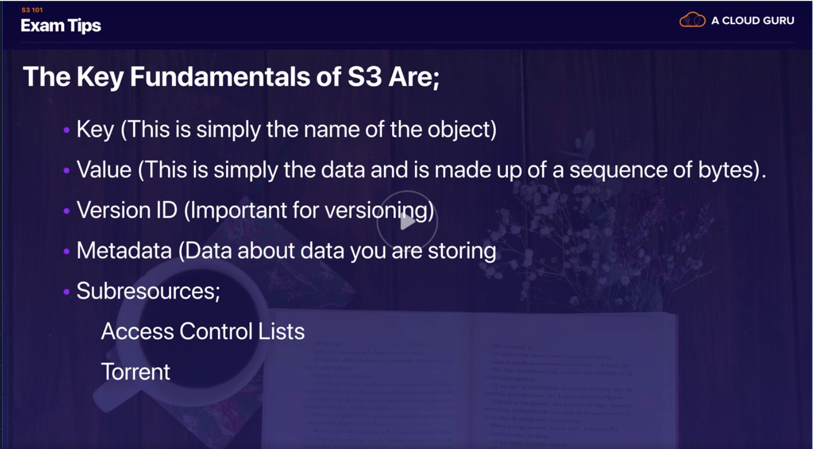







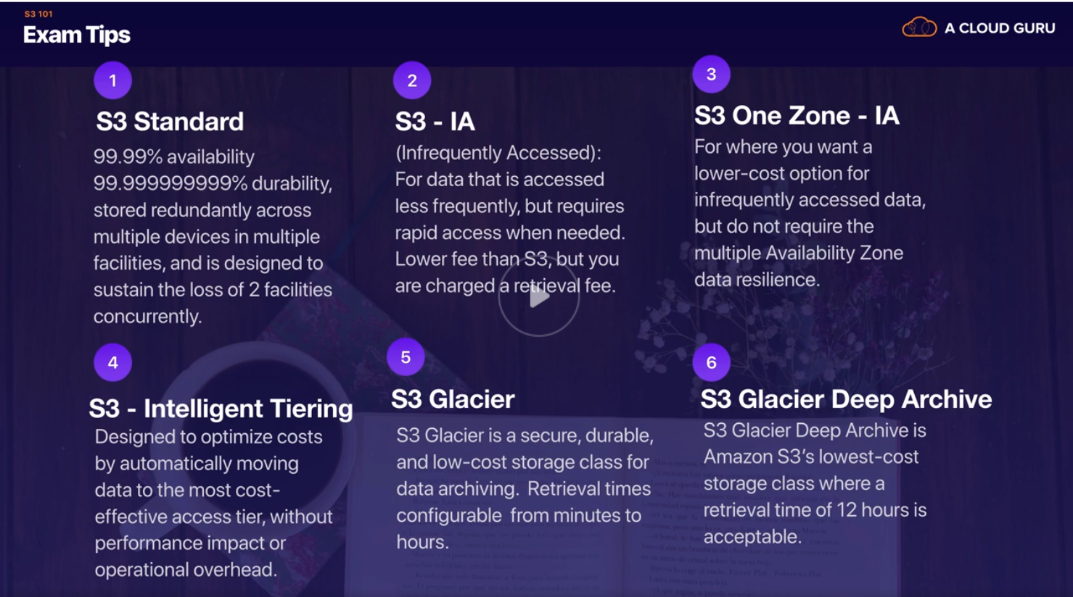

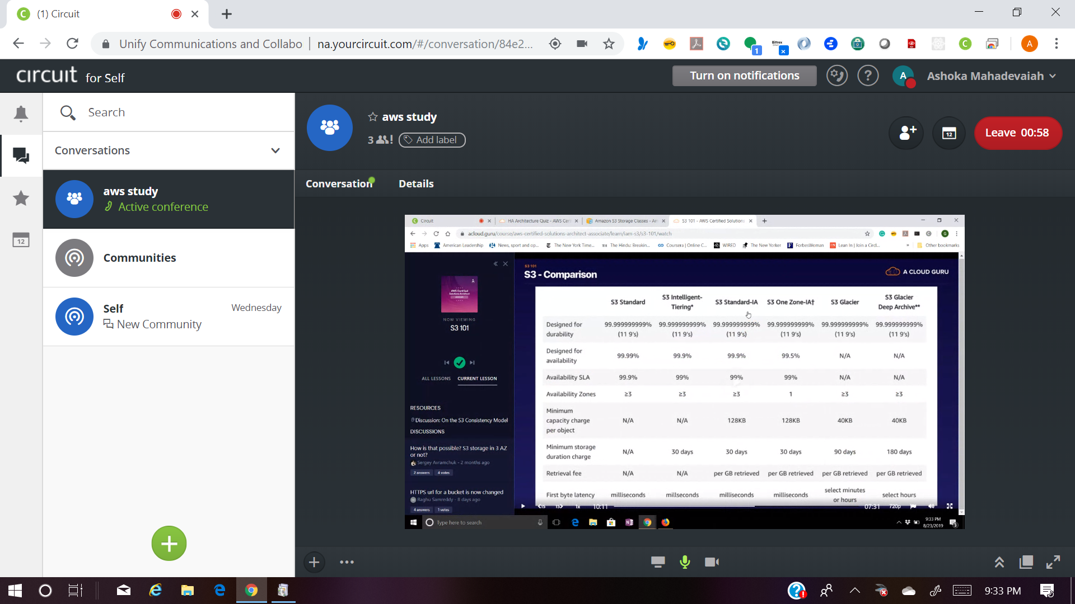

<https://docs.aws.amazon.com/AmazonS3/latest/dev/storage-class-intro.html>

<https://docs.aws.amazon.com/AmazonS3/latest/dev/storage-class-intro.html>

<https://docs.aws.amazon.com/autoscaling/ec2/userguide/what-is-amazon-ec2-auto-scaling.html>

<https://aws.amazon.com/rds/details/read-replicas/>

<https://aws.amazon.com/rds/details/read-replicas/>

<https://aws.amazon.com/rds/details/multi-az/>

<https://www.whizlabs.com/blog/s3-one-zone-ia-vs-s3-standard-ia/>

Amazon S3 Reduced Redundancy Storage

Reduced Redundancy Storage (RRS) is an Amazon S3 storage option that enables customers to store noncritical, reproducible data at lower levels of redundancy than Amazon S3’s standard storage. It provides a highly available solution for distributing or sharing content that is durably stored elsewhere, or for storing thumbnails, transcoded media, or other processed data that can be easily reproduced. The RRS option stores objects on multiple devices across multiple facilities, providing 400 times the durability of a typical disk drive, but does not replicate objects as many times as standard Amazon S3 storage.



NO CDN



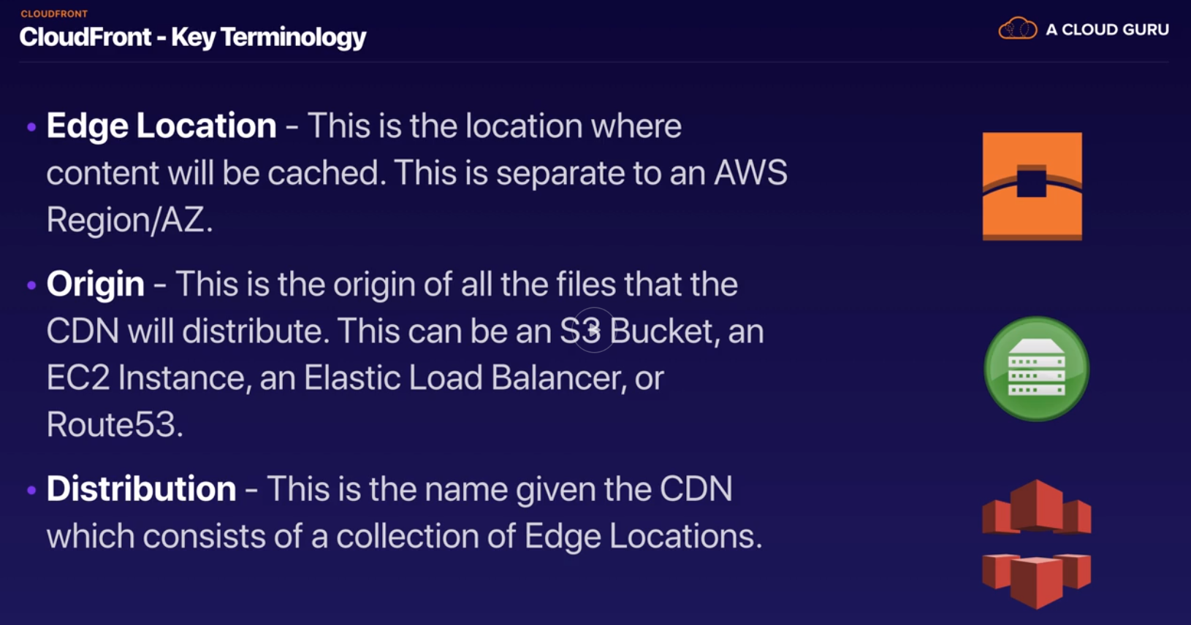

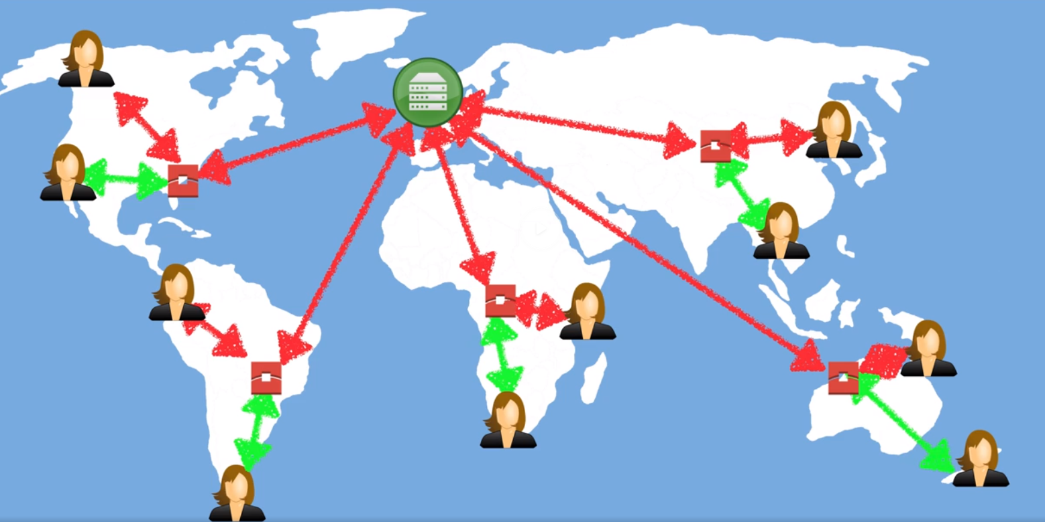

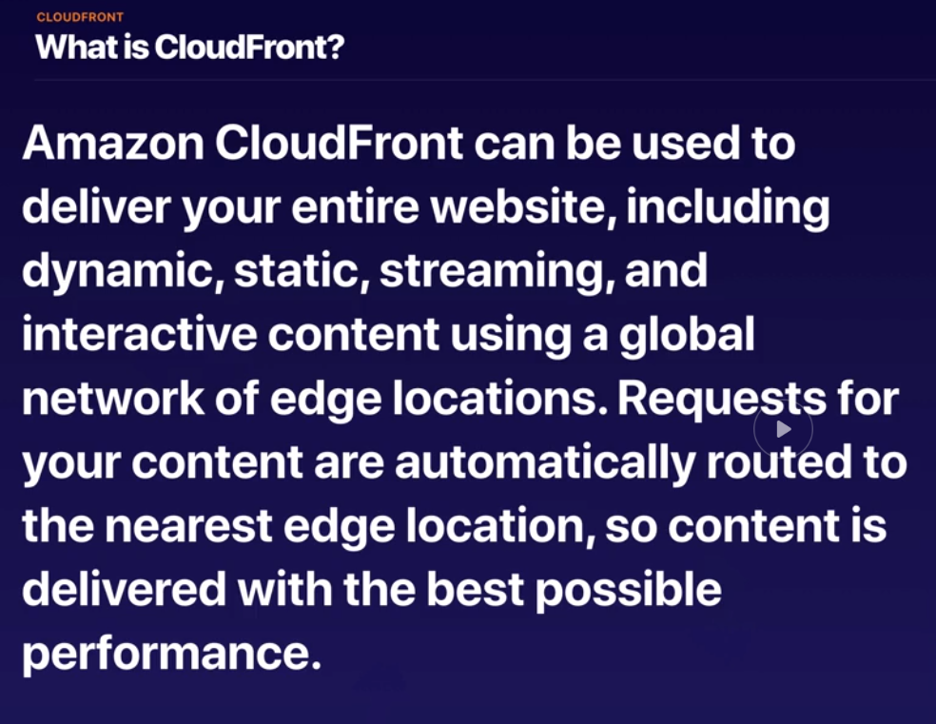

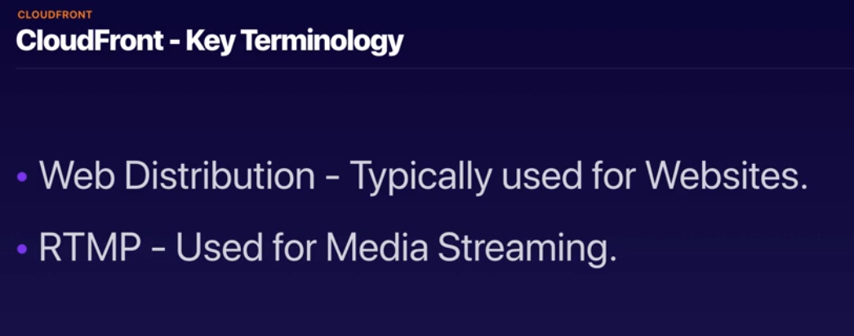

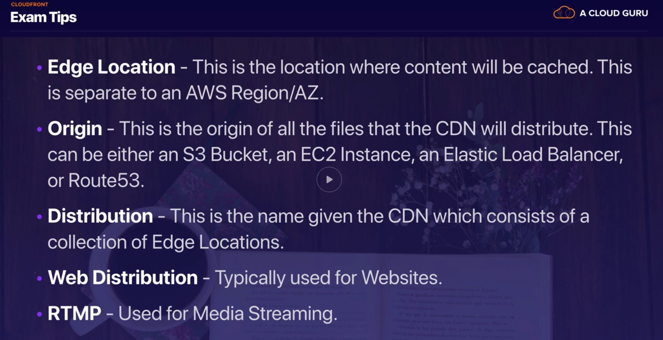

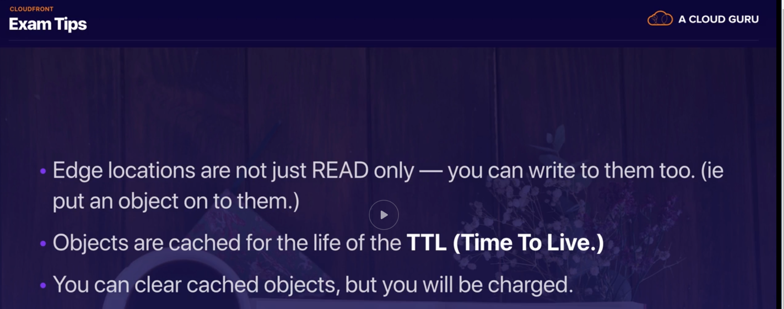



BLAAAAAAAAAA



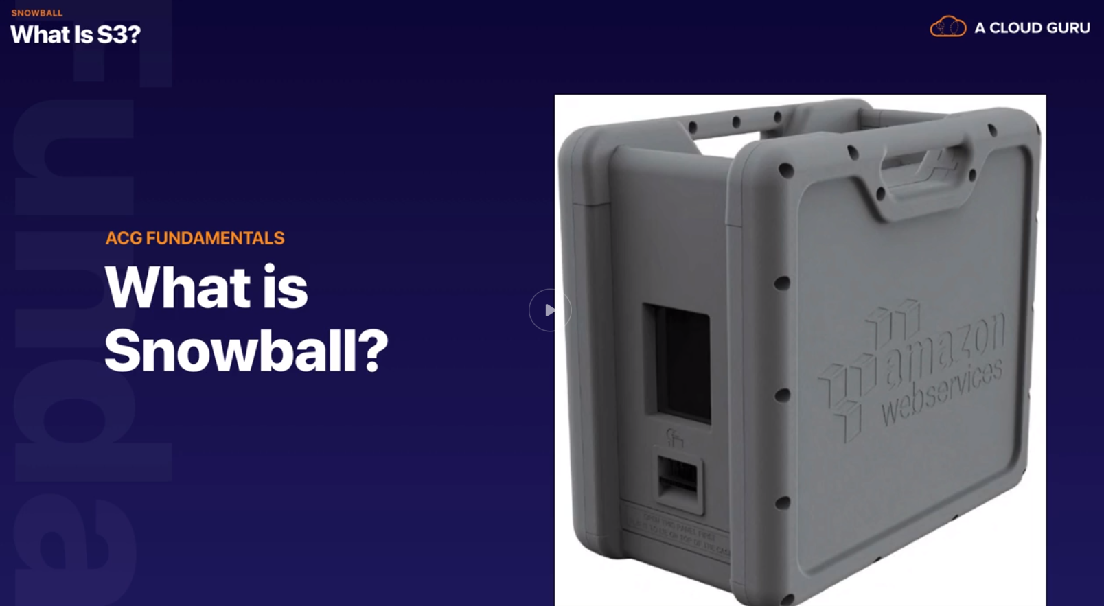

BIG BIG DISCKS

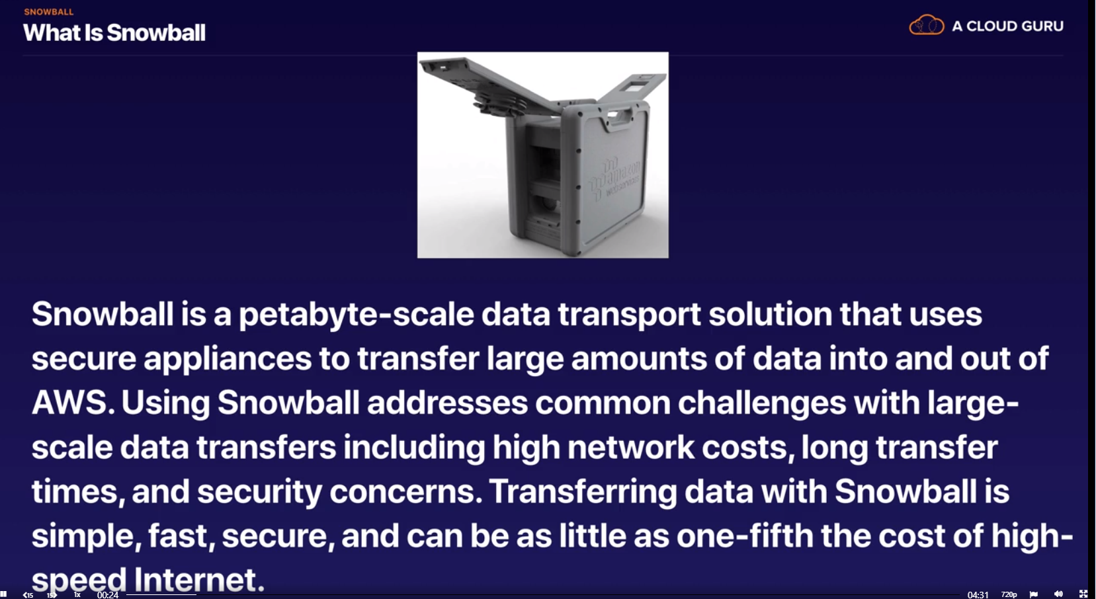

When doing large transfers reduce the cost by 1/5 compared to internet

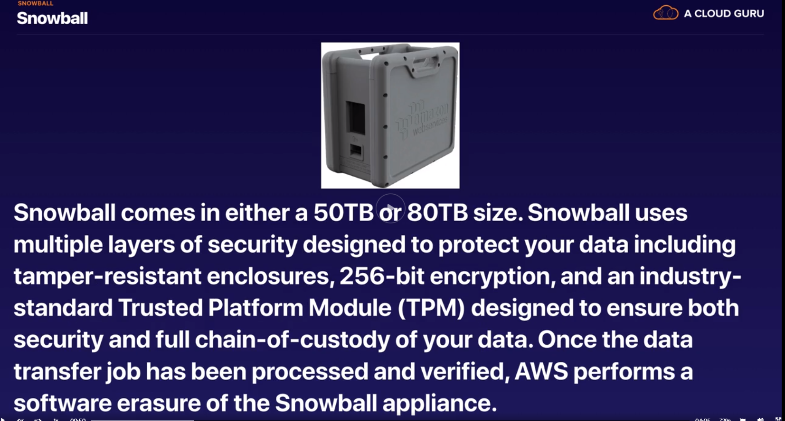

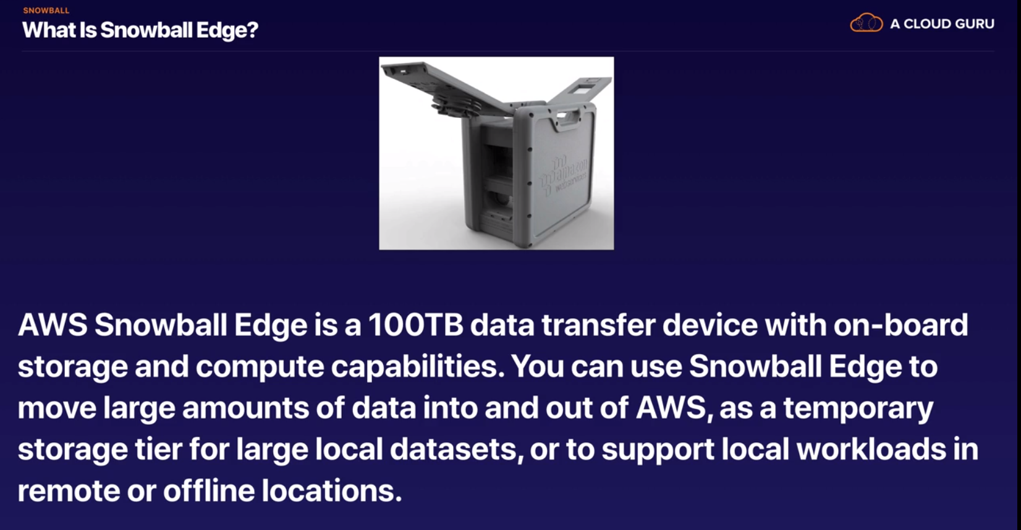

This gives compute (run lambda functions) capability along with storage

Acts as mini offline AWS

